**St. Paul**

**UNITED CHURCH OF CHRIST**

**October 12, 2025 10:30am**

***Welcome!*** Whether you are a guest, friend or member, we are delighted that you are here. Large print bulletins are available at either door. Ask a greeter for any directions you may need.

*“Please note that this service will be live-streamed on Facebook. If you do not wish to be visible on camera, please let an usher know so we can take appropriate measures to ensure*

*your privacy."*

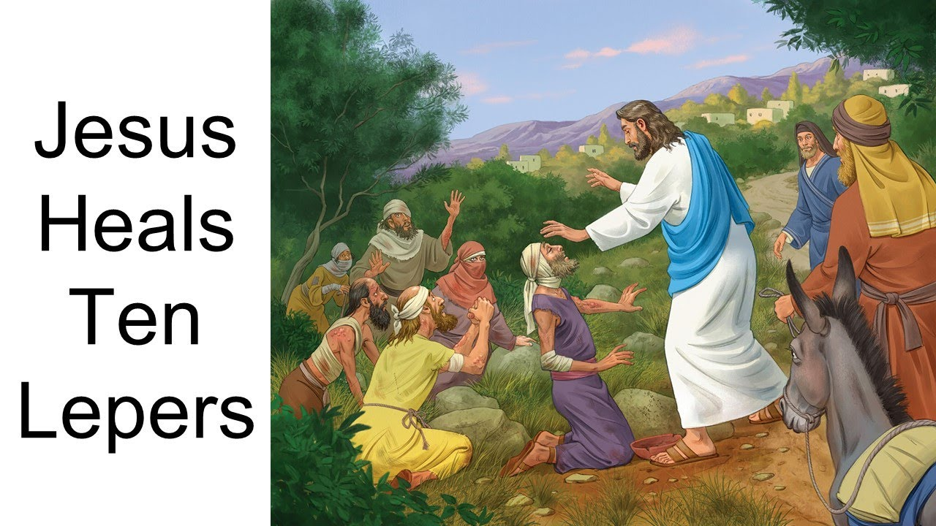

Rev. Jim Oleson, Pastor

Carolyn Meier, Musician

***Eighteenth Sunday after Pentecost***

*\*Please rise in body or spirit*

**Ringing of the Bell**

**Welcome & Announcements**

*In the last days, says God, I will pour out my Spirit upon all people. Your sons and daughters shall prophesy. Your young people shall see visions, and your old people shall dream dreams. People of God, we have been baptized into one Spirit and one body through Jesus Christ. Let us worship today.*

**Prelude and Lighting of the Candles**

**\*** **Call to Worship**

**One:** A word of encouragement came from prophet to people;

**Many: Live a life that is full – build, plant, eat, love, multiply—**

**One:** Pray for your communities.

**Many: Keep God in the center of all that is.**

**One:** We enter into worship today with hope in our hearts

**Many: For something happens here that reminds us that we can live as God desires**

**One:** God has made a promise of faithfulness to us

**Many: And we can trust the promise.**

**\*Invocation**

**We stand in awe of you, Most Gracious God.**

**You love your people no matter the circumstance. You want us to live meaningful lives with you at the center. So, we say to you, Loving God - Come!**

**Send your Holy Spirit to dwell with us in our worship. Open our hearts to receive and our minds to be challenged by the teachings of Jesus the Christ. This we pray. Amen.**

**\*Hymn of Praise** #304 New CenturyAll Hail the Power of Jesus’ Name

**\*Prayer for Transformation** **and New Life**   
**We cannot sing our praise to you O God, when we dishonor your creation. We cannot sing our praise to you O God, when we use our voices to defame others. We cannot sing our praises to you O God, when we claim for ourselves the honor due to you. We cannot sing our praises to you O God, when we fail to recognize your healing work.**

**In order that we might sing we need you and nothing else at the center of our lives. Place new desires in our hearts so that we sing to you and to you alone. We make this prayer to you, O God from the places within our being where a reminder of your love is needed. Amen.**

<pause for silent reflection >

**Words of Grace**   
**Leader:** Even when we feel ourselves exiled and far from God, even when we forget to sing God’s praises, God assures us that he has not forgotten us!

**People:** **We are comforted by God’s promise of forgiveness and love.**

**\*Response of Praise**

**Glory be to the Father, and to the Son, and to the Holy Ghost; As it was in the beginning, is now, and ever shall be, World without end. Amen. Amen.**

**Written Word** Jeremiah 29:1, 4-7

2 Timothy 2:8-15

Luke 17:11-19

**Hymn** #493 New Century O Jesus, I Have Promised

**Message** Community and Wholeness Rev. Jim Oleson

Lamentations 3:22-23

**Church in Prayer**

**Pastoral Prayer**

**Lord’s Prayer** (Debts, Debtors)

**Offertory**

**Invitation to Generosity**

**\*Doxology** (Tune: Old Hundredth)

**Praise God, from Whom all blessings flow; Praise Him, all creatures here below;**

**Praise Him above, ye heavenly host; Praise Father, Son, and Holy Ghost. Amen.**

**\*Prayer of Dedication**

**Gracious God, accept these gifts as evidence of our desire to participate with you in the care of your beloved. These gifts symbolize our thanksgiving for all that you provide.**

**Through these gifts we praise you, O God. Amen.**

**\*Closing Hymn #**55 New Century Rejoice, You Pure in Heart

\***Commission and Benediction**

**\*Christ’s Light Leads Us into the World**

**\*Congregational Response** #76 New Century Sent Forth by God’s Blessing

(Verse 1)

**\*Ringing of the Bell and Postlude**

903 Meier Road, Old Monroe, Missouri 63369

[stpauluccom@gmail.com](mailto:stpauluccom@gmail.com)

Website: stpauluccom.com

636-665-5329

**OFFICE HOURS**

Wednesday: 9:00am – 3:00pm

Friday: 9:00am - Noon

It Happens

Here St. Paul UCC

Weekly Calendar

October 12th - October 19th

**October 12th *Eighteenth Sunday after***

***Pentecost***

9:15am Bible/Book Study

10:30am Worship

11:30am Carry in Dinner

**October 19th *Nineteenth Sunday after***

***Pentecost***

9:15am Bible/Book Study

10:30am Worship

***Looking Ahead***

October 22-29 Pastor Jim on vacation

October 26th Hymn Sing

________________________________________________________________________________________

**OUR GIVING IN 2025**

**Needed weekly to meet our commitments** $**2317.02 $ 2317.02**

General Fund Offering October 5th $2910.00 September Average $ 1010.00 Stewardship Offering October 5th $ 545.00 August Average $ 1285.00

______ ____________________________________________________ ____________________ ________

**HAPPENING IN OUR COMMUNITY**

**Thursday, October 16:** Outsmart the Scammers at St. John’s UCC in Weldon Springs. 12:30pm Light Refreshments. 1:00pm Presentation. Keynote Speaker: Doug Anstedt from Edward Jones.

**Sunday, October 19:** Chili & Roast Beef Dinner at Ebenezer UCC in Augusta. Dine in or carry out. Serving from 11:00am to 5:30pm.

**Saturday, November 1**: Holiday Bazaar & Silent Auction at St. John’s UCC in Weldon Springs. Fun for the whole family from 9:00am to 3:00pm.

**Saturday, November 1:** Tukey Supper at Friedens UCC in Moscow Mills. Serving from 3:00pm-6:00pm. Dine in or carry out.

**Thank you to all our volunteers!**

**Greeters/Ushers**

Rick Kincer & Mary Anne Lee

**Acolyte**

Joyce Noble

**Liturgist**

**Fellowship Hour**

Carry in Dinner

In our prayers …

This week we added the Jerry and Mary C. to our prayers.

We continue to keep in our prayers: Lauretta, Lynn and Ron D., Lori S., Mike S., Brittney, Debbie & Tony, Bernadette, James C., Mike S., Carrie B., Ruth and Stephanie, the family of Bonnie, and the Burke family.

We lift up in our prayers those who need prayers for their *long-term circumstances*: Carol Jean P.

Emergency Planning is checking into a CPR/AED refresher course.  There are 2 options: refresher course without certification at no cost or a certification course at the cost of $40. Let Joyce Noble know if you are interested.

We have one new programmable thermostat on the south side of the sanctuary. We are testing temperature settings. Please do not adjust the temperature.